The Residential Operators | Framework by Steven Rea

Operating Support Starter Pack
Choose one recurring task and build the help your team needs to do it. This pack contains four editable templates and a connected make-ready example. You can start with one document; a complete set is not required.

Choose where to start
The question people need answered | Start with
Why does this area exist and who owns it? | Domain overview
What happens, who is responsible and when? | SOP
How do I complete this task? | Work instruction
What must I check while doing the work? | Job aid

First check existing guidance. An answer may be buried, outdated, unclear, or written for another role. If the company has not decided the expectation, identify who can decide before writing instructions.

Use the pack
- Ask a practitioner to show the task, including exceptions and where someone else must decide.
- Copy the relevant template into a separate Word file. Replace bracketed prompts, add rows or space as needed, and remove template instructions.
- Link related guidance by its actual title and location. Keep task instructions and job aids directly accessible.
- Have a teammate try it during the work. Revise what is missing or unclear, confirm the expectation with its owner, and put the current version where the team will use it.

Go to a template or example
Domain overview | SOP | Work instruction | Job aid
Open the completed make-ready example directory
The templates are starting structures. The sample make-ready rules, roles, and Turn Board tool are illustrative and are not NorthPoint procedures. Confirm your own standards, permissions, and decision authority.

Editable template | Purpose and boundaries

Domain overview template
Copy this page. Replace the prompts and expand only what the reader needs.

Area of work
[Name the business area this overview describes]

Purpose and outcome
[Why this area exists and what it is responsible for achieving]

Scope and boundaries
[What is included, what is outside this area, and where related work belongs]

Connections to the business
[Which teams or processes provide inputs or depend on this area]

Operating ownership
[Who decides expectations and resolves questions about scope or responsibility]

Guidance ownership
[Who maintains the documents, how users report a mismatch, and what changes should prompt a review]

Related procedures
[List the title and link or location of each relevant SOP]

Document details
[Owner or contact / updated date / draft or approved status]

Editable template | Milestones and responsibilities

SOP template
Copy this page. Describe the process and its decisions; link detailed task instructions.

Procedure and outcome
[Name the procedure and the result it should produce]

Where it fits and when it begins
[Related domain / preceding work / trigger / conditions that must be true before starting]

Process owner and participating roles
[Who owns the process and which roles take part]

Flowchart of the phases
[Insert a flowchart showing the phases in order, role handoffs, decision points, and paths for correction or exceptions]

Milestones and responsibilities
Add or remove rows. Name the evidence or condition that allows work to move on.
Milestone | Responsible role | Ready to move on when
[Starting milestone] | [Role] | [Condition or evidence]
[Next milestone] | [Role] | [Condition or evidence]
[Completion milestone] | [Role] | [Condition or evidence]

Stops and decisions
[What should stop or return for correction, who resolves it, and who needs an update]

Procedure complete
[Required outcome and how someone can verify it]

Connected guidance and document details
[Domain, work instruction and job aid titles with links / owner or contact / updated date / status]

Editable template | How to complete one task

Work instruction template
Copy this page. One role, tool, and outcome are a useful default; split at meaningful handoffs.

Task and outcome
[Name the task and the result the user will produce]

Role and tool
[Who performs this task and where they do it]

Before starting
[Trigger, permissions, information, materials, and decisions needed]

Task steps
Pair the steps with screenshots from your tool. Crop and highlight the relevant fields or controls; show the expected result. Keep the written actions clear and update screenshots when the tool changes.
Step | Action | Expected result or check
1 | [Action and matching screenshot] | [Visible result]
2 | [Action and matching screenshot] | [Visible result]
3 | [Action and matching screenshot] | [Visible result]

If something goes wrong
[Specific condition / stop or recovery action / person who can resolve the question]

Done with this task
[What to verify in the saved result and any next person or action]

Connected guidance and document details
[Parent SOP and job aid titles with links / owner or contact / updated date / status]

Editable template | Checks beside the work

Job aid template
Copy this page. Keep only the reminders needed at the moment of action.

Job aid title
[Name the check, reference, or moment this supports]

For whom and when
[Role / the point in the task when this is useful]

Checks at the point of use
[ ] [Observable condition to check]
[ ] [Observable condition to check]
[ ] [Observable condition to check]
[ ] [Saved result to verify, if applicable]

If a check fails
[What to stop, correct, or ask, and who can resolve it]

Need the full steps or the reason
[Work instruction title and link / SOP or standard title and link]

Document details
[Owner or contact / updated date / draft or approved status]
If the task needs a short reference or worked example rather than a checklist, replace the checks with that format.

Completed teaching example | Six connected documents

Make ready example directory
Follow one vacant home from assessment through authorized release. These documents demonstrate different kinds of support for the same work. They are newly authored examples, not NorthPoint procedures.

The process at a glance
Scope > Approve > Complete > Pressure test > Release
If the pressure test fails, correct the work and retest. Completed work orders do not establish readiness; the example property manager verifies and records release.

Open a document
Domain overview: Maintenance
SOP: Unit make-ready once vacant
Work instruction: Record a make-ready scope in Turn Board
Work instruction: Pressure test
Job aid: Scope creation checklist
Job aid: Pressure-test checklist

Follow the connections
Maintenance -> Unit make-ready once vacant -> two selected tasks: record the scope and pressure test. Each task has a job aid. The two instructions expand selected tasks; they are not an exhaustive set of technical repair instructions.

Adapt before use
Replace the fictional tool and sample roles with your own. Confirm readiness standards, entry permissions, approvals, required inspections, exception owners, and how release is communicated. Do not treat example statuses or dates as company policy.

When the work changes
Tool steps change: check instructions and their job aids. Responsibility or milestones change: revisit the SOP and affected task support. Purpose or scope changes: revisit the domain overview and its connected guidance.
Framework attribution: Steven Rea, Four layers of operating support, developed from Year One Episode 7 recording discussions. The method is early operating guidance and does not establish measured results. Written support works alongside practice, coaching, and judgment.
Return to the starting guide

Illustrative make-ready example | Domain overview

Maintenance
Keep homes and property systems in working condition through maintenance, repairs, and vacant-unit make-ready.
Area owner: Property operations manager
Guidance owner: Operations support lead
Teaching example only. Adapt the operating expectations to your company before use.

Purpose
Maintenance supports the condition and function of homes throughout occupancy and vacancy. It connects assessment, planned maintenance, repairs, and verification of completed work. Unit make-ready once vacant is one procedure within this domain.
A target ready date helps people plan. Only a verified, authorized release establishes Ready in this example.

Scope and boundaries
- Includes preventive maintenance, corrective repairs, condition assessment, and vacant-unit make-ready.
- Connects maintenance staff and vendors with property operations, residents, and leasing. Each procedure defines its own trigger, roles, and completion criteria.
- For unit make-ready once vacant, possession and permission to enter must be confirmed. Entry, spending authority, technical repair methods, and required inspections follow their applicable company standards; this sample does not define those standards.

Who maintains this area
The property operations manager owns maintenance expectations and resolves unclear responsibilities. The operations support lead maintains this guidance with the people who plan, perform, and check maintenance work. For vacant-unit make-ready, the property manager owns the release decision.
Report an unclear or outdated instruction to the support lead. Take an unresolved readiness decision to the property operations manager; keep the home unreleased while it is unresolved.

A procedure within this area
Unit make-ready once vacant connects the whole turn within maintenance. The linked work instructions expand two tasks: recording the initial scope and pressure testing the home before release.
Open SOP: Unit make-ready once vacant
Return to the example directory

Illustrative make-ready example | SOP

Unit make ready once vacant
Coordinate the work, resolve exceptions, and release the home only after its readiness has been verified.
Process owner: Property operations manager
Roles: Coordinator, trades, property manager, leasing
Begins: Unit vacant; possession and access confirmed
Ends: Verified release recorded; leasing informed
Teaching example only. Adapt the operating expectations to your company before use.

Process flowchart
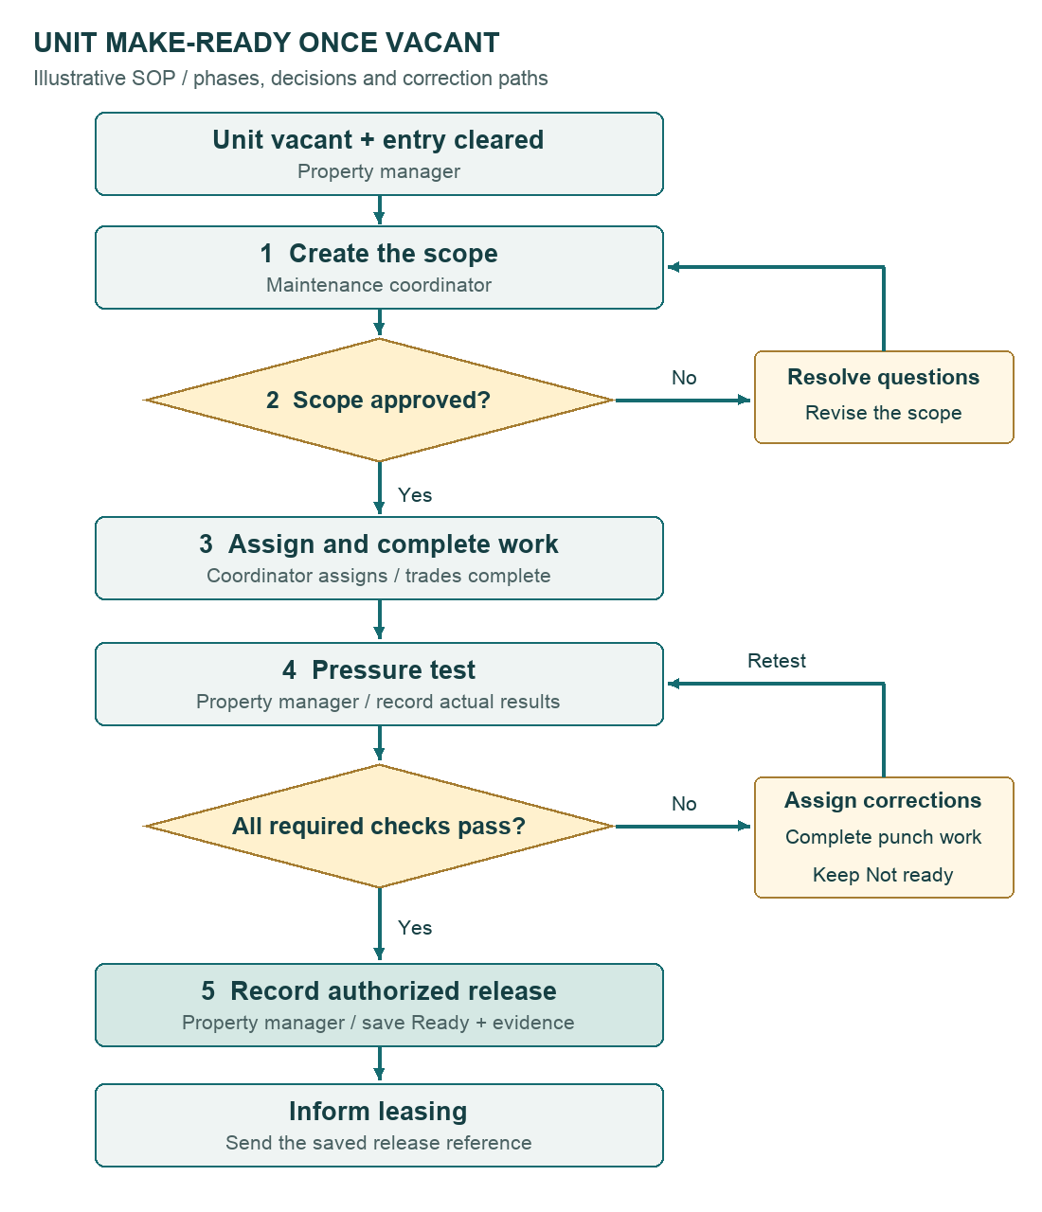
One process with two decision points. Approval and a passed pressure test are required before release.

Unit make-ready once vacant | Continued

Before the scope walk
The property manager confirms the unit is vacant, possession is established, and entry is permitted under the applicable company rules. The maintenance coordinator opens the home's turn record with its target ready date and current condition marked Not ready. The target is a planning date, not a release.

The readiness rule
Completed work orders do not make the home Ready. The property manager must verify the approved scope and applicable readiness standard, resolve required punch items, and record the authorized release. Until then, the home stays Not ready.
The coordinator owns follow-up on unfinished work. The property manager owns the release decision. Leasing uses the saved release status when communicating readiness.

Milestones and responsibilities

1 Assess the home and record the scope
Responsible: Maintenance coordinator
Walk the home after entry is cleared. Record each finding, proposed work, evidence, and missing decision. Submit the scope for review.
Open the scope work instruction

2 Approve the scope and assign the plan
Responsible: Property manager + maintenance coordinator
The property manager confirms approval within the applicable spending authority or obtains the required authorization. The coordinator assigns each approved item to a trade or vendor, records its target completion, and sequences repairs, cleaning, and inspection. Share the current target ready date with leasing.

3 Complete and document the work
Responsible: Assigned trades or vendors; coordinator follows up
Each assigned person completes approved work and records the result and required evidence. The coordinator checks remaining items and dependencies. New findings return for scope review; delays trigger a revised plan and an update to the property manager and leasing.

4 Pressure test and resolve the punch list
Responsible: Property manager; coordinator assigns corrections
After required work and cleaning are recorded complete, pressure test the home against the approved scope and readiness standard. Record failed checks as punch items with an owner and target date. Reinspect corrections before release.
Open the pressure-test work instruction

5 Authorize release and inform leasing
Responsible: Property manager
When all required checks pass, save the release with the inspection evidence, decision owner, and date. Verify the saved Ready status, then tell leasing which home has been released and link the record.
Use the pressure-test checklist

When the process stops or changes
- Entry or possession unclear: stop the scope walk and return the issue to the property manager.
- Unapproved work or a new finding: the coordinator records it and seeks the required approval before that work proceeds.
- A missed target or failed final check: keep Not ready, assign the remaining work, and update the target and leasing's expectations.
- Readiness standard unclear: the property operations manager resolves the expectation. A target date or move-in commitment does not waive a required check.
See the failed pressure-test steps

Procedure complete
The saved record contains the approved scope, work completion evidence, passed pressure test, resolved required punch items, and the property manager's release. Leasing has received the release reference.
Why the release matters: Maintenance
Return to the example directory

Illustrative make-ready example | Work instruction

Record a make ready scope in Turn Board
Capture the home's condition and proposed work clearly enough for the property manager to review.
Role: Maintenance coordinator
Tool: Turn Board - fictional example
Start condition: Possession and entry cleared
Outcome: Scope saved and submitted for review
Teaching example only. Adapt the operating expectations to your company before use.

Have these ready
- The correct home's turn record and confirmed entry permission.
- The current company readiness standard and applicable inspection requirements.
- Access to capture location-specific findings and supporting photos.
Keep the scope creation checklist beside you

Steps in the example tool

1. Open the home's turn record.
Match the property and home identifier. Confirm Not ready and the target ready date. If entry is not cleared, stop and contact the property manager.
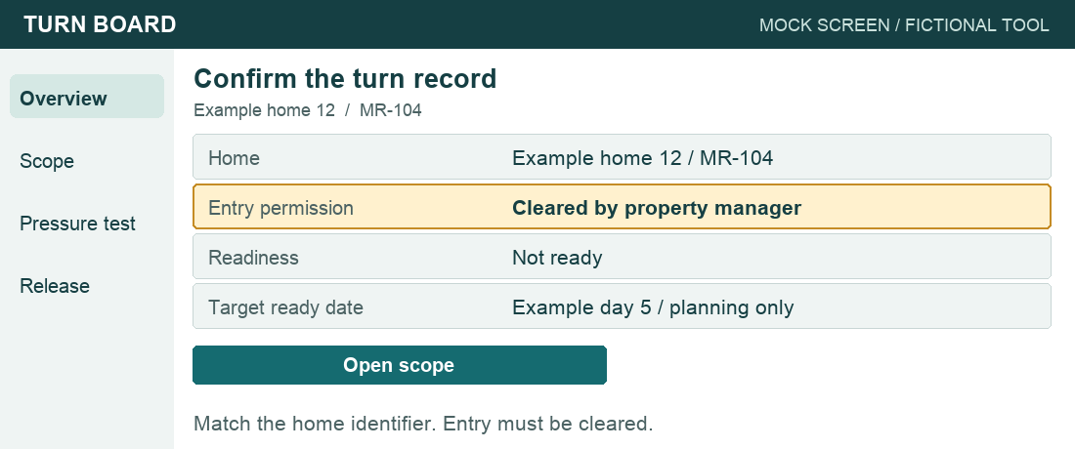
Step 1 · Match the home and confirm entry before starting.

Record a make-ready scope in Turn Board | Continued

2. Walk and record by location.
In Scope, add each finding with its room or location, observed condition, proposed work, and supporting photo or note. Use the readiness standard and scope creation checklist to cover the home.
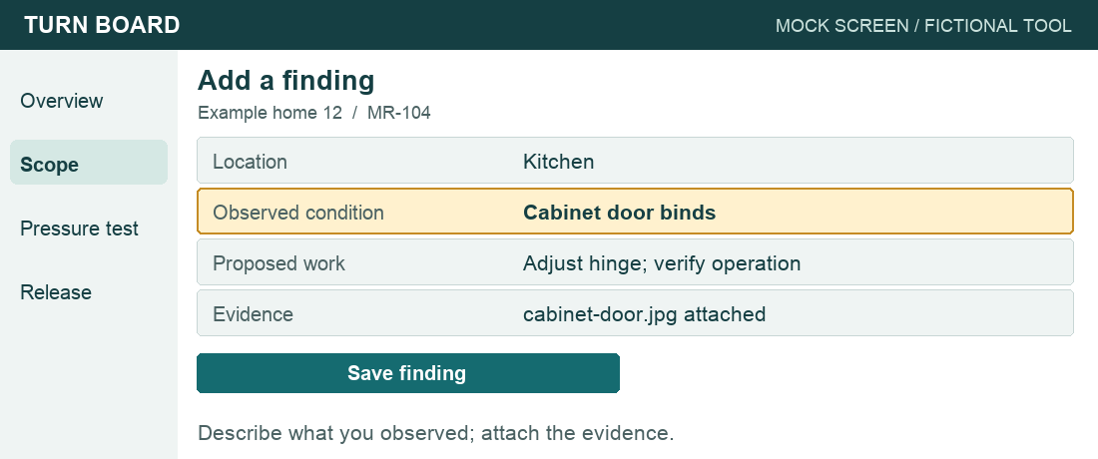
Step 2 · Record a specific condition and proposed work.

3. Separate a finding from an approval.
For example: Kitchen · cabinet door binds · adjust hinge and verify operation. Mark the item Awaiting approval. Record any estimate or specialist assessment needed for a decision; do not treat proposed work as authorized.
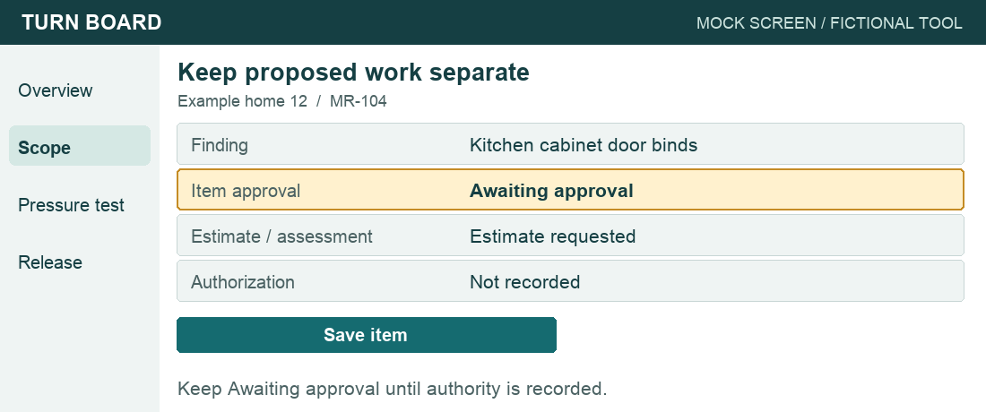
Step 3 · A saved finding is not authorization to do the work.

Record a make-ready scope in Turn Board | Continued

4. Identify sequence and open questions.
Note dependencies such as completing repairs before final cleaning. Record missing information and the decision needed. Leave areas you could not assess visibly unresolved.
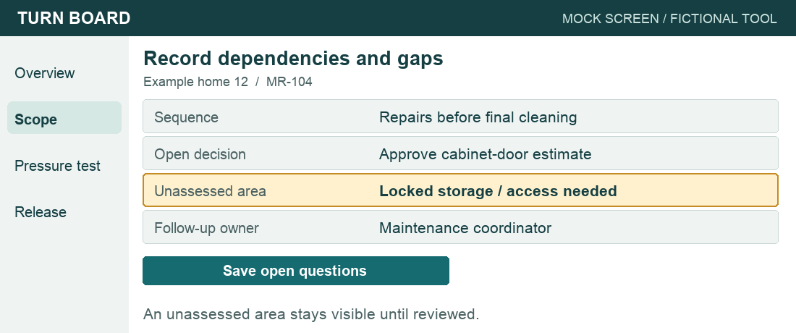
Step 4 · Make dependencies and unanswered questions visible.

5. Submit the scope for review.
Choose Submit scope. Select the property manager as reviewer and save. Read back the findings, evidence, open questions, and Scope awaiting review status.
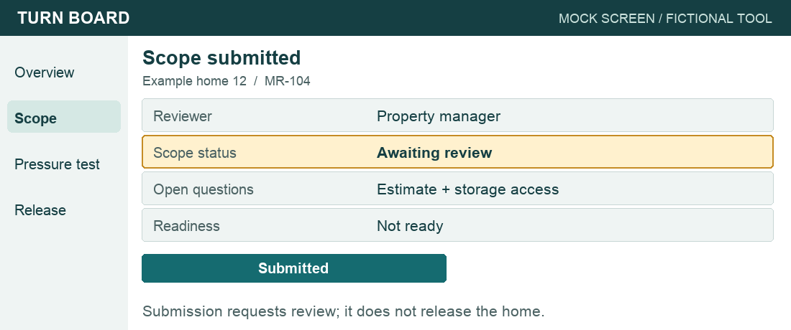
Step 5 · After Submit scope, read back the saved status and reviewer.
What happens after review? See the SOP milestones

Record a make-ready scope in Turn Board | Continued

Done with this task
The saved scope is available to the named property manager for review. The coordinator follows up on open questions. Approval, assignment, and execution are later SOP milestones; the home remains Not ready.

Turn Board Illustrative scope record
Field | Example value
Home | Example home 12 · MR-104
Readiness | Not ready
Scope status | Awaiting review
Finding | Kitchen cabinet door binds
Proposed work | Adjust hinge; verify operation
Item approval | Awaiting approval
Reviewer | Property manager

If the scope cannot be completed
Record the inaccessible area, missing assessment, or tool failure. Tell the property manager what prevents review. Keep the scope incomplete until the missing information is resolved; a blank field is not evidence that no work is needed.
Return to the example directory

Illustrative make-ready example | Work instruction

Pressure test
Pressure test the completed make-ready: check that the home and finished work function as intended and meet the readiness standard before recording Ready.
Role: Property manager
Tool: Turn Board - fictional example
Start condition: Required work and cleaning recorded complete
Outcome: Release recorded, or punch work assigned
Teaching example only. Adapt the operating expectations to your company before use.

Before the pressure test
Open the correct home's record. Have the approved scope, work evidence, current readiness standard, and required inspection records available. If required work is still open, return it to the coordinator before attempting release.
Open the pressure-test checklist

Steps in the example tool

1. Review the completed work.
In Pressure test, compare recorded completion with the approved scope. Confirm required inspection records are present. A completed task status alone is insufficient evidence of readiness.
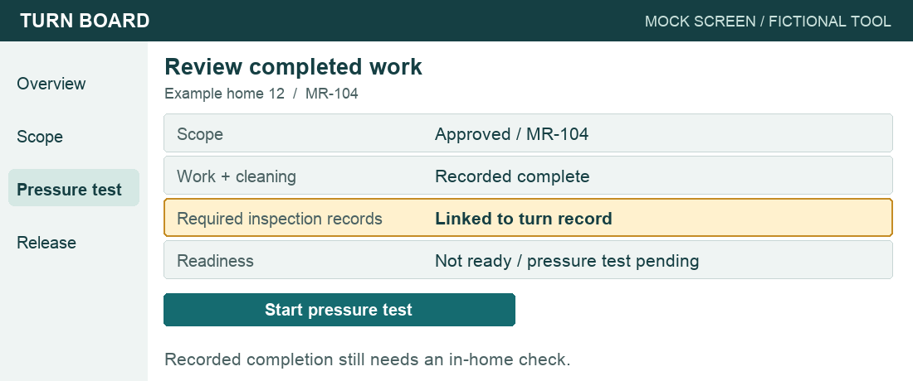
Step 1 · Check the approved scope and completion evidence.

Pressure test | Continued

2. Pressure test the home.
Walk the home against the company readiness standard. Verify the finished work, cleaning, and required checks. For the cabinet-door item, confirm it operates as intended. Record each check's result and evidence; use the exception path for any failure or unverified item.
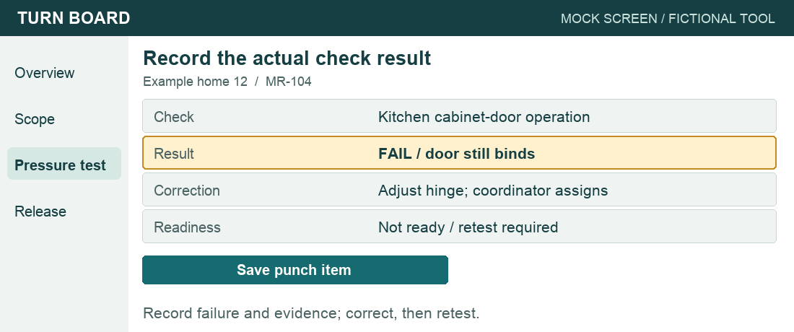
Step 2 · A failed check becomes a punch item, then a retest.

3. Confirm the release conditions.
Confirm all required checks pass, required punch items are resolved and reinspected, and keys/access arrangements are ready under the applicable standard.
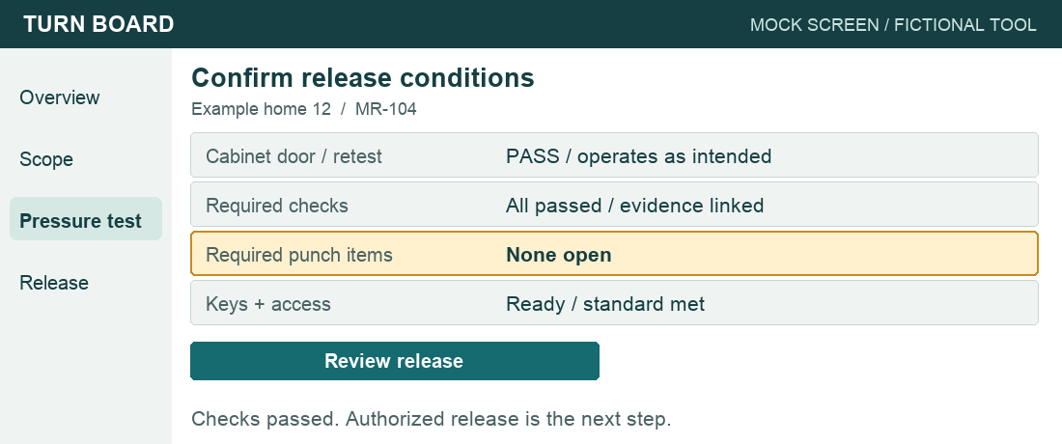
Step 3 · After correction and retest, confirm every release condition.
Use the pressure-test checklist

Pressure test | Continued

4. Record the authorized release.
Choose Release home. Save Ready with the passed inspection, your identity as release owner, and the release date. Read back the saved status and evidence before communicating release.
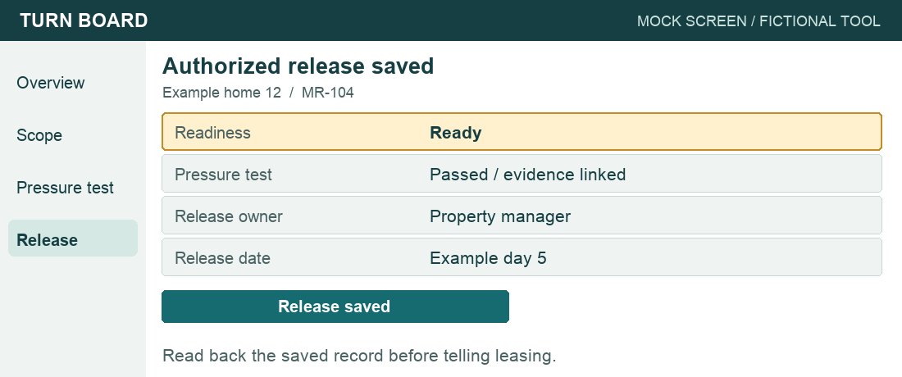
Step 4 · After Release home, verify the saved release and evidence.
Read the SOP readiness rule

5. Inform leasing.
Send leasing the home identifier and saved release reference. Record that notification in the turn record. If the notification fails, resolve it before treating the overall procedure as complete.
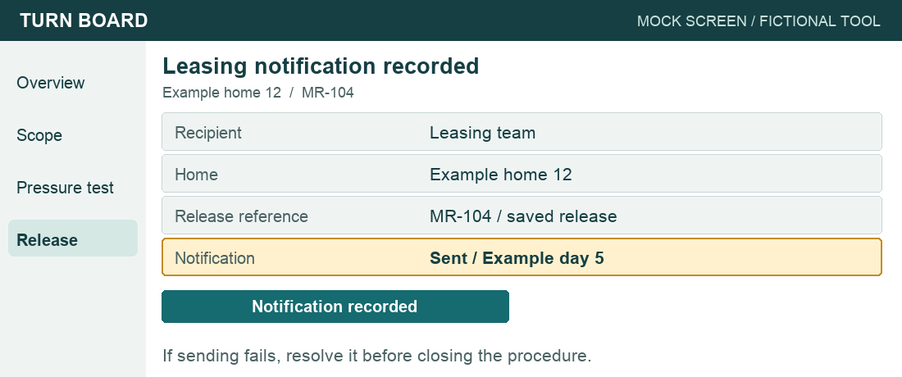
Step 5 · Confirm leasing received the saved release reference.

Pressure test | Continued

If a pressure test check fails
Keep Not ready. In Punch list, record the location, failed condition, evidence, and correction needed. Send it to the coordinator for assignment and a target completion date; verify those are recorded. Update leasing on the pending release and revised target. After correction, retest the item and any affected checks, then repeat the pressure-test checklist.
If the standard itself is unclear, ask the property operations manager for a decision. If the tool cannot save the inspection or release, keep the release pending and resolve the recording problem before telling leasing the home is Ready.
See the SOP exception owners

Done with this task
Either the saved release is verified and leasing has been informed, or the home remains Not ready with specific punch work assigned and its next pressure test pending. A failed pressure test never becomes Ready just because the target date arrived.

Turn Board Illustrative record after correction and reinspection
Field | Example value
Home | Example home 12 · MR-104
Scope and work | Approved; required work complete
Pressure test | Passed; evidence linked
Cabinet-door check | Operation verified after adjustment
Required punch items | None open
Readiness | Ready
Release owner / date | Property manager · Example day 5
Leasing notification | Release reference sent · Example day 5

Return to the example directory

Illustrative make-ready example | Job aid

Scope creation checklist
Use alongside the company readiness standard to capture reviewable findings.
For: Maintenance coordinator
Use when: Walking the home to build the scope
Teaching example only. Adapt the operating expectations to your company before use.

Capture before submitting
[ ] Correct home; possession and entry permission confirmed.
[ ] Each room and applicable exterior area reviewed against the readiness standard.
[ ] Surfaces, doors, cabinets, fixtures, appliances, and cleaning needs captured as applicable.
[ ] Each finding names a location, observed condition, proposed work, and supporting evidence.
[ ] Required specialist assessments, access issues, and unassessed areas are visible.
[ ] Dependencies and approval questions are recorded; proposed work is not marked approved.
[ ] Saved scope shows the property manager as reviewer; home remains Not ready.

If a check cannot be completed
Record the gap and tell the property manager what is needed. Follow applicable safety and entry procedures for hazards or access restrictions. Do not represent an unassessed area as checked.

Need the steps or the next milestone
Show the steps: Record a make-ready scope
See approval and assignment in the SOP
Return to the example directory

Illustrative make-ready example | Job aid

Pressure test checklist
Keep this beside the pressure test and release record.
For: Property manager
Use when: Deciding whether to release the home
Teaching example only. Adapt the operating expectations to your company before use.

Before choosing Release home
[ ] Correct home and approved scope reviewed.
[ ] Required work and cleaning verified in the home.
[ ] Applicable readiness checks passed; required inspection records available.
[ ] Required punch items corrected and reinspected; no unresolved release blockers.
[ ] Keys and access arrangements meet the applicable readiness standard.

After saving the release
[ ] Saved record shows Ready, inspection evidence, release owner, and release date.
[ ] Leasing has received the home identifier and saved release reference; notification is recorded.

A check fails or remains unverified
Keep Not ready. Record the specific punch item or missing decision, route it to its owner, and update leasing. Reinspect corrections before release. A planned ready date does not override the checks.
Show the failed pressure-test steps

Need the steps or the reason
Open the pressure-test work instruction
Read the SOP readiness rule
Return to the example directory

